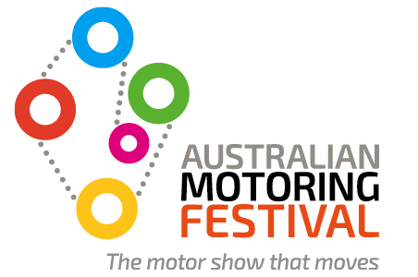

MEDIA RELEASE 12 February 2014
Ferrari, Mercedes-Benz and Toyota to feature at Australian Motoring Festival
Ferrari, Mercedes-Benz and Toyota have been announced as the first featured brands at the inaugural Australian Motoring Festival, to be held from 26-29 March at the Melbourne Showgrounds.
The Australian Motoring Festival is a joint initiative between VACC and RACV which will feature four action-packed days of unparalleled automotive showcases and driving experiences, unlike anything seen before in Australia. It will differ from a traditional display-style motor show by providing visitors with multiple opportunities to interact with vehicles and vehicle technology through test drives and simulation.
Herbert Appleroth, CEO of Ferrari Australasia, said the upcoming festival is the perfect opportunity for Ferrari to share the spirit and passion of the brand with Australian fans, and to inspire the dreams of the fans of the future.
“We are absolutely delighted to be a featured brand at the Australian Motoring Festival. This is a unique opportunity for lovers of cars to get close and personal with our brand and our beautiful vehicles. Our Ferrari Experience display area will feature 30 years of Ferrari supercar history and a stunning Ferrari showroom with the latest range of Ferrari roadcars. The Australian Motoring Festival is an event that no Ferrari enthusiast will want to miss,” said Appleroth.
Horst von Sanden, CEO of Mercedes-Benz Australia/Pacific, said that the festival will be a great opportunity to introduce their brand to a wider audience in an interactive, live arena.
“The Australian Motoring Festival will be an excellent platform for Mercedes-Benz to showcase the latest safety technology and performance vehicles. We will be featuring Mercedes-AMG models and the Mercedes-Benz Driving Academy during the festival, along with a few surprise vehicles,” said von Sanden.
Stephen Slater, Southern Regional Manager at Toyota Australia said, “The Australian Motoring Festival will be a great opportunity to let motoring enthusiasts look, feel and touch all the different vehicles in our extensive range and experience the technology in an interesting, interactive environment. We’re really excited to be involved, and look forward to bringing festival patrons into the Toyota family.”
Geoff Gwilym, Executive Director at Victorian Automobile Chamber of Commerce, said that the involvement of Ferrari, Mercedes-Benz and Toyota will ensure that the festival offers Australian automotive enthusiasts a diverse mix of vehicles and experiences.
“These three global brands are among the largest in the industry across the luxury sports, prestige and everyday categories. We would like to thank them for supporting the inaugural year of the Australian Motoring Festival. We are confident that the festival will offer them the opportunity to connect with the Australian driving public in a new and dynamic way.”
Gordon Oakley, General Manager RACV Motoring and Mobility said that the event is shaping as a fantastic occasion for RACV’s 2.1 million members to experience first-hand some of the world’s iconic motoring brands and models.
“The Australian Motoring Festival will be an interactive experience that provides members, their families and visitors a vast array of memorable and informative motoring activities. This event is designed for everyone; it is affordable and another great event where RACV members will benefit from significant savings on entry tickets.”
The Australian Motoring Festival will be held from 26-29 March at the Melbourne Showgrounds. Tickets start from $30 for adults and $20 for children, with RACV and VACC members saving more than 30% on ticket prices. For more information and to purchase tickets, visit the website at www.australianmotoringfestival.com.au
- ENDS -
For media enquiries please contact:
Tom Hughes | Client Manager Dig&Fish | 03 9827 4466 | 0400 121 538 | tom.hughes@digandfish.com
A joint initiative by

